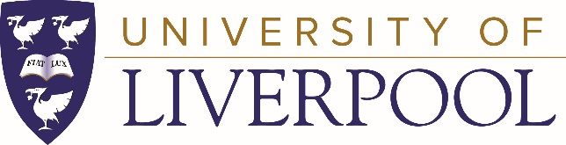
Leverhulme Trust Early Career Fellowships at the School of Histories, Languages & Cultures, University of Liverpool
The University of Liverpool’s School of Histories, Languages & Cultures invites expressions of interest for the 2021 Leverhulme Early Career Fellowships scheme. These awards aim to provide career development opportunities for early career researchers (less than five years since their doctoral viva) who have a proven record of research but have not held a full-time permanent academic post in the UK. They enable Fellows to undertake a significant piece of publishable work and should lead to a more permanent academic position. Further information, including eligibility criteria, can be found on the Leverhulme Trust website.
The University of Liverpool is one of the United Kingdom’s leading research institutions with an annual turnover of £400 million, including £140 million for research. Liverpool is ranked in the top 1% of universities worldwide and is a member of the prestigious Russell Group, comprising the leading research universities in the United Kingdom.
The Department of Modern Languages & Cultures comprises staff working across a wide range of language-based studies, including literary and media, film, historical, cultural and sociolinguistic studies. Alongside French, German, Spanish and Italian, the department also offers Film Studies and Chinese, and we are one of only two centres in the UK where you can study the full range of Hispanic Languages, including Basque, Catalan, Portuguese and Spanish.

The department is an active participant in the School’s inter-disciplinary research centres, including the Centre for the Study of International Slavery, the Centre for Medieval and Renaissance Studies and the Eighteenth-Century Worlds research centre. Since 2010, we have been part of the School of Histories, Languages and Cultures, one of four Schools in the Faculty of Humanities and Social Sciences. The School also includes the departments of History, Irish Studies, Politics, and Archaeology, Classics and Egyptology.

Those interested in applying for a Fellowship at the University of Liverpool are invited to submit expressions of interest to hlcrsrch@liverpool.ac.uk by 12pm on Wednesday 18th November 2020. You are strongly encouraged to discuss your research proposal with a potential mentor within the Department well in advance of submitting your expression of interest. Please include the following documents:

- CV (2 pages maximum)
- A completed pro-forma template: Leverhulme ECR 2021 pro-forma
- A list of publications (1 page maximum). This should include forthcoming publications and publications in preparation.
- Identification of potential mentor

Applicants supported by the Department and School will be informed by 16th December 2020. All shortlisted candidates will be invited to attend a virtual workshop on 11th January 2021, which will include presentations and advice about the scheme.
An expert panel will peer review successful applications after the workshop, and candidates will be invited to send their fully developed application outline (using the template available on the Leverhulme Trust Grant Application System) by 5pm on 20th January 2021.

